**Confidential**
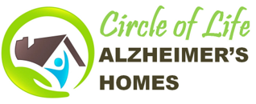
CIRCLE OF LIFE ALZHEIMER'S HOMES, L.L.C.
Susan E. Wielechowski, Director
5620 West Corliss Circle Prescott, AZ, 88305
(928) 237 4795 susan@circleoflifecare.com www.circleoflifecare.com

Resident’s Name___________________________ Date of Birth______________

Resident Disaster Orientation Acknowledgement (Circle of Life Alzheimer's Homes, L.L.C. hereinafter referred to as "COLAH, L.L.C.")

I or my representative have been oriented to the emergency procedures of Circle of Life Alzheimer’s Homes, LLC per their policy and procedures:
- Entry/Exit Doors
- How to Open/Close Windows
- Fire Extinguisher Locations
- Smoke Detectors’ Locations
- Assembly Areas for Drills and/or Emergencies
- Location and Operation of Telephones
- Evacuation Plan and the Location of its Hallway Placement on Each Floor (If there is More than One Floor)
- Evacuation Drills and their Types
- Disaster Plan Including Relocation Steps to be Taken

Acknowledgements

Resident’s or Responsible Party’s Signature

_________________________________________________________

Full Printed Name________________________________________________________

Date__________________

In Witness Thereof:

Signature of COLAH, L.L.C. Witness_________________________________________

Full Printed Name________________________________________________________

Date__________________

